Chapter 17, Solution 74.

(a) A_{n} = 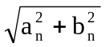, φ = tan^{–1}(b_{n}/a_{n})

A₁ = 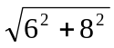 = 10, φ₁ = tan^{–1}(6/8) = 36.87°

A₂ = 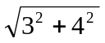 = 5, φ₂ = tan^{–1}(3/4) = 36.87°

i(t) = {4 + 10cos(100πt – 36.87°) – 5cos(200πt – 36.87°)} A

(b) p = 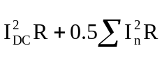
= 2[4² +0.5(10² + 5²)] = 157 W

